Leung, Cristian K (Student)


OSPF Lab

Purpose:
The purpose of this lab was to learn how to configure a multi-area OSPF network, involving several routers and switches to increase routing efficiency, scalability, and organization. We use PuTTY in this lab for command-line access to make configurations in the network and to verify that we have completed our task.

Background Information:
OSPF or Open Shortest Path First is a link-state routing protocol that finds the best path between routers. Developed by IETF, it’s an open standard protocol that anyone can implement. The main goal of OSPF is to find the shortest and most efficient path for data to travel through a network and uses a SPF algorithm to calculate the best route. OSPF uses link-state information which is details about connections and their statuses of all the routers in the same area. OSPF uses this information to automatically update routes when a network change occurs like new router being added or a router being downed and it’s very fast and reliable.
A multi area OSPF is when a network splits multiple areas of OSPF rather than just having the entire network in one area. Each area has its own group of routers and only exchange link-state information with those in its own area. This is mainly used to make OSPF more efficient and scalable by reducing size of routing tables, decreasing network traffic caused by sharing link-state information, and speeding up convergence/calculations used when network changes occur. Multi area OSPF works by having a “backbone area” which is also known as Area 0 where all the areas connect to. This area is like the main road for all the other smaller areas to travel to each other so in a way they’re still connected and one network. The other areas are non-backbone areas which handle local routing similar to what was explained in the OSPF description. ABR or Area Border Router is the router that connects one or more areas to Area 0 and summarizes routes between areas kind of like a doorway for each area to Area 0.
PuTTY is the tool we use the most in this lab, almost the entire lab is done using it. PuTTY is a free, open-source terminal emulator and networking tool used to connect to remote computers/network devices from a Windows machine. It basically lets you log in to another system over the network using command-line interfaces. It was created by a British programmer Simon Tatham and was first released in 1999. Currently it’s maintained by the PuTTY development team as an open-source software. In summary it’s a really useful tool for network engineers, system admins, cybersecurity students etc. to configure devices like servers, routers, and switches.
In this lab we use Cisco devices like their routers and switches. A router is a networking device that connects multiple networks together and directs data to their destinations. To do this they support routing protocols like OSPF, EIGHRP, BGP, and RIP. They also perform NAT (Network Address Translation) so private devices can share one public IP. Other uses for routers are they can act as a firewall or VPN gateway which is for security. Routers are really essential for internet connectivity, interconnecting different subnets or VLANs, network security, remote access, traffic management, and route optimization. The other device we use are switches. Switches are another networking device that connects multiple devices within the same network. Basically, they use MAC address tables to send data to the right device and operate at Layer 2 though some switches are Layer 3 with routing abilities like routers.
Lab Summary:
This lab is about configuring a multi-Area OSPF setup using Cisco routers and PuTTY to configure them. Routers are divided into separate areas, and all connected together by Area 0. In this lab we configured IP addresses and OSPF areas using CLI commands through PuTTY and afterward used ping commands to verify connectivity between all networks. We also used the command “ip show ospf neighbor” to verify the OSPF neighbor relationships. In summary we practiced making a multiple OSPF areas to provide more scalability and optimization for a network.

Configuration:
Topology:
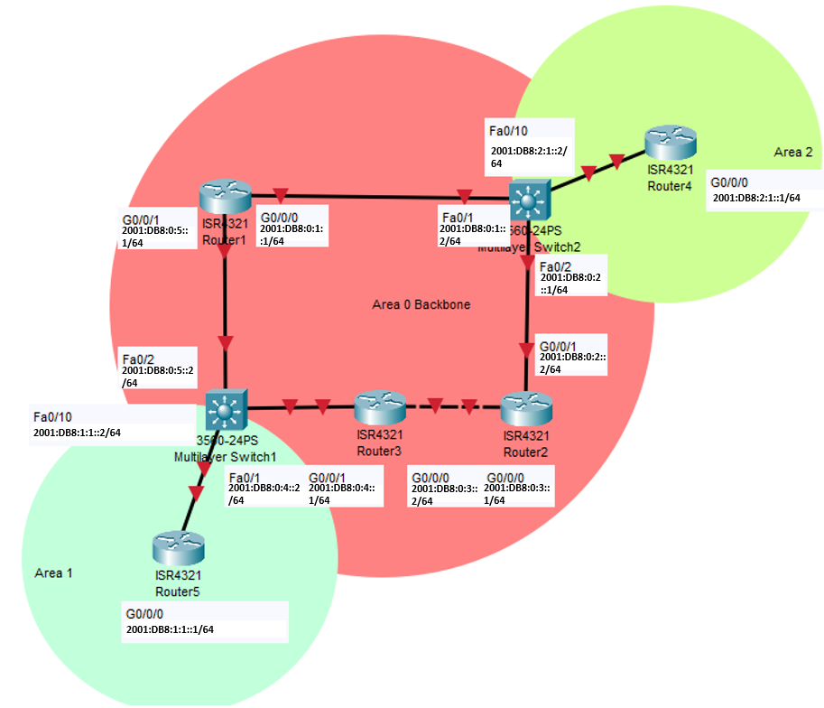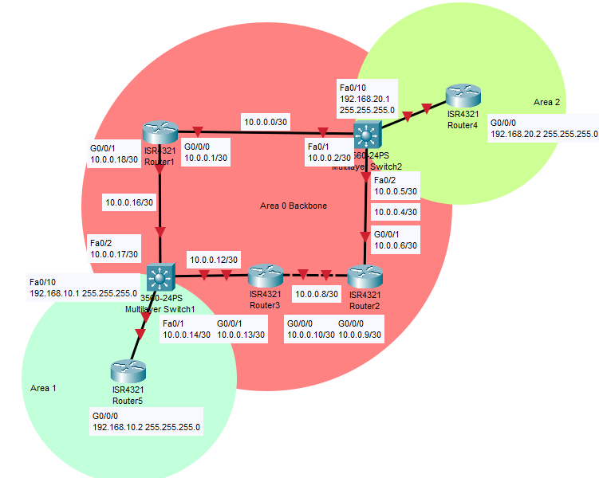
Connect console cable into routers to configure them with Ips, Areas Subnet, and Router IDs. To do this follow the commands below:
Router 1
Commands in PuTTY:
enable
configure terminal
hostname R1
ipv6 unicast-routing
interface g0/0/0
ip address 10.0.0.1 255.255.255.252
ip ospf 1 area 0
ipv6 address 2001:DB8:10::1/64
ipv6 ospf 1 area 0
no shutdown
interface g0/0/1
ip address 10.0.0.5 255.255.255.252
ipv6 address 2001:DB8:11::1/64
ipv6 ospf 1 area 0
ip ospf 1 area 0
no shutdown
router ospf 1
router-id 1.1.1.1
network 10.0.0.0 0.0.0.3 area 0
network 10.0.0.4 0.0.0.3 area 0
show run (It should look the same as below after the show run command)
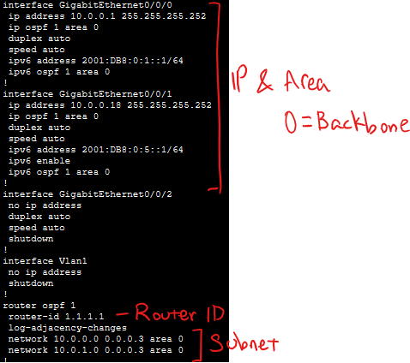
Router 2
Commands in PuTTY:
enable
configure terminal
hostname R2
ipv6 unicast-routing
interface g0/0/0
ip address 10.0.0.9 255.255.255.252
ipv6 address 2001:DB8:0:3::1/64
ip ospf 1 area 0
ipv6 ospf 1 area 0
no shutdown
interface g0/0/1
ip address 10.0.0.6 255.255.255.252
ipv6 address 2001:DB8:0:2::2/64
ip ospf 1 area 0
ipv6 ospf 1 area 0
no shutdown
router ospf 1
router-id 2.2.2.2
network 10.0.0.0 0.0.0.3 area 0
network 10.0.0.8 0.0.0.3 area 0
show run
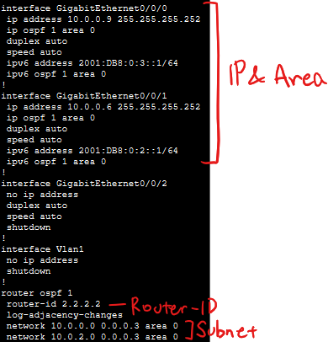
Router 3
Commands in PuTTY:
enable
configure terminal
hostname R3
ipv6 unicast-routing
interface g0/0/0
ip address 10.0.0.6 255.255.255.252
ipv6 address 2001:DB8:11::2/64
ip ospf 1 area 0
ipv6 ospf 1 area 0
no shutdown
interface g0/0/1
ip address 10.0.0.13 255.255.255.252
ipv6 address 2001:DB8:13::1/64
ip ospf 1 area 0
ipv6 ospf 1 area 0
no shutdown
router ospf 1
router-id 3.3.3.3
network 10.0.0.4 0.0.0.3 area 0
network 10.0.0.12 0.0.0.3 area 0
show run
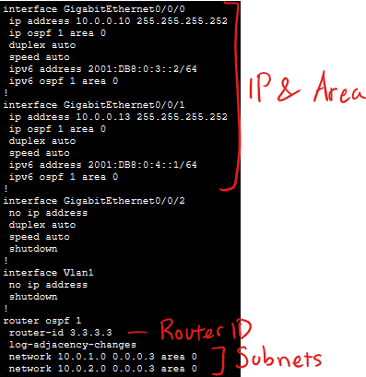
Switch 1
Commands in PuTTY:
enable
configure terminal
hostname S1
ip routing
interface fa0/1
no switchport
ip address 10.0.0.14 255.255.255.252
ipv6 address 2001:DB8:0:4::2/64
no shutdown
interface fa0/2
no switchport
ip address 10.0.0.17 255.255.255.252
ipv6 address 2001:db8:0:5::2/64
no shutdown
interface fa0/10
no switchport
ip address 192.168.10.1 255.255.255.0
ipv6 address 2001:db8:1:1::2/64
no shutdown
router ospf 1
router-id 10.10.10.10
network 10.1.0.0 0.0.0.3 area 1
network 10.1.1.0 0.0.0.3 area 0
network 10.1.10.0 0.0.0.255 area 0
show run
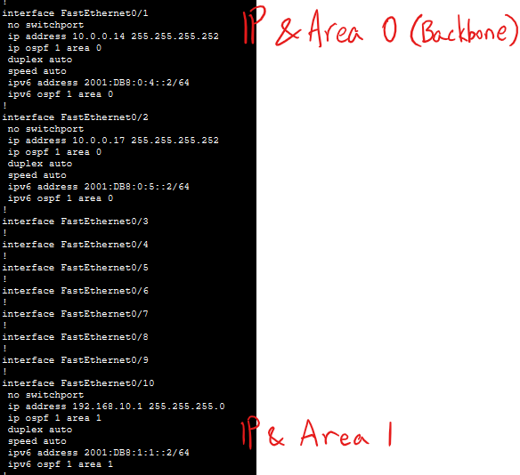
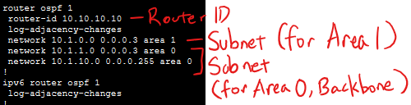
Switch 2
Commands in PuTTY:
enable
configure terminal
hostname S2
ip routing
interface fa0/1
no switchport
ip address 10.0.0.2 255.255.255.252
ipv6 address 2001:DB8:0:1::2/64
no shutdown
interface fa0/2
no switchport
ip address 10.0.0.5 255.255.255.252
ipv6 address 2001:db8:0:2::1/64
no shutdown
interface fa0/10
no switchport
ip address 192.168.20.1 255.255.255.0
ipv6 address 2001:db8:2:1::2/64
no shutdown
router ospf 1
router-id 11.11.11.11
network 10.2.2.0 0.0.0.3 area 0
network 10.2.10.0 0.0.0.255 area 0
network 10.2.0.0 0.0.0.3 area 2
show run

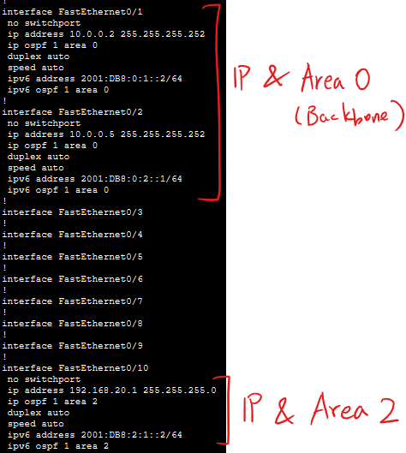
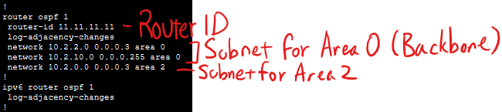
Router 4
Commands in PuTTY:
enable
configure terminal
hostname R4
ipv6 unicast-routing
interface g0/0/0
ip address 192.168.20.2 255.255.255.0
ipv6 address 2001:DB8:2:1::1/64
ip ospf 1 area 2
ipv6 ospf 1 area 2
no shutdown
router ospf 1
router-id 4.4.4.4
network 10.0.0.12 0.0.0.3 area 2
network 10.0.0.16 0.0.0.3 area 2
show run
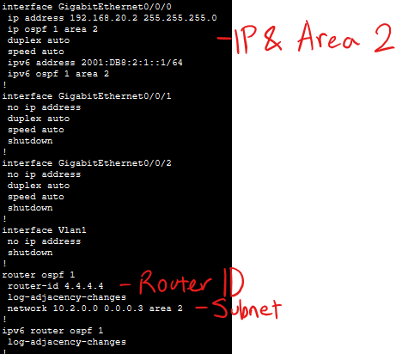
Router 5
Commands in PuTTY:
enable
configure terminal
hostname R5
ipv6 unicast-routing
interface g0/0/0
ip address 192.168.10.2 255.255.255.0
ipv6 address 2001:DB8:1:1::1/64
ip ospf 1 area 1
ipv6 ospf 1 area 1
no shutdown
router ospf 1
router-id 5.5.5.5
network 10.0.0.12 0.0.0.3 area 1
network 10.0.0.16 0.0.0.3 area 1
show run
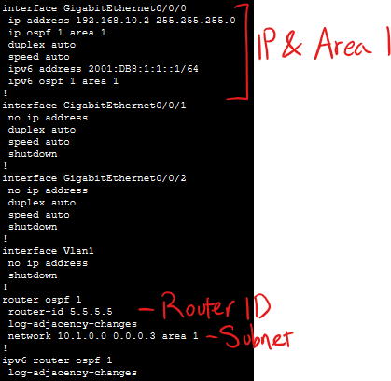

Verifying that OSPF is functioning (show ip ospf route)
Router 1
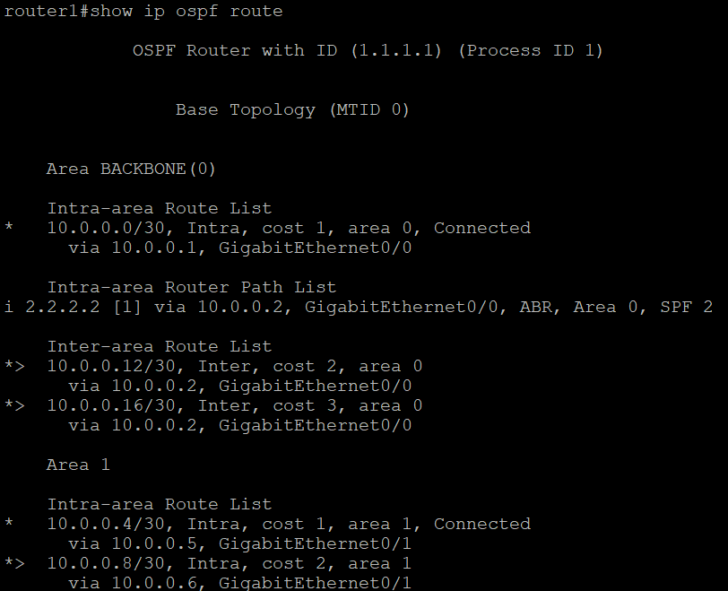
Router 2
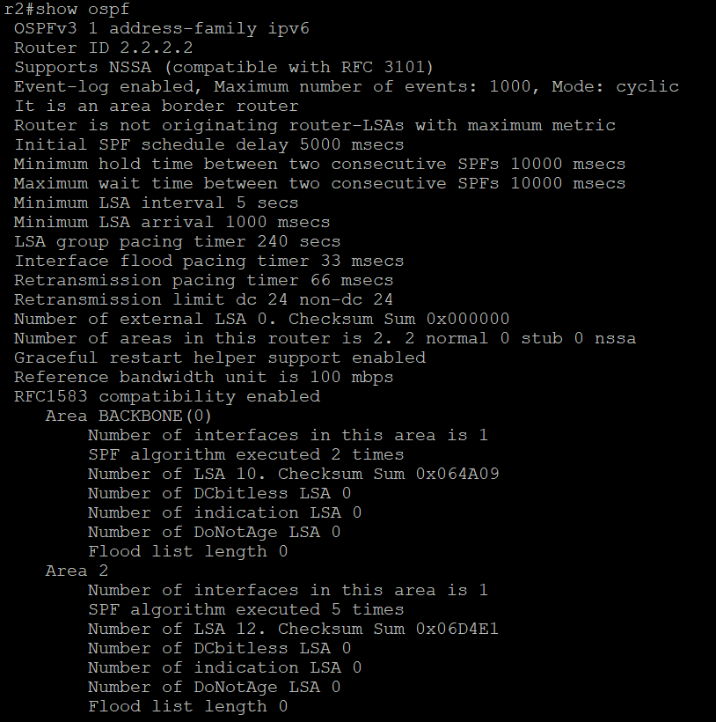
Router 3
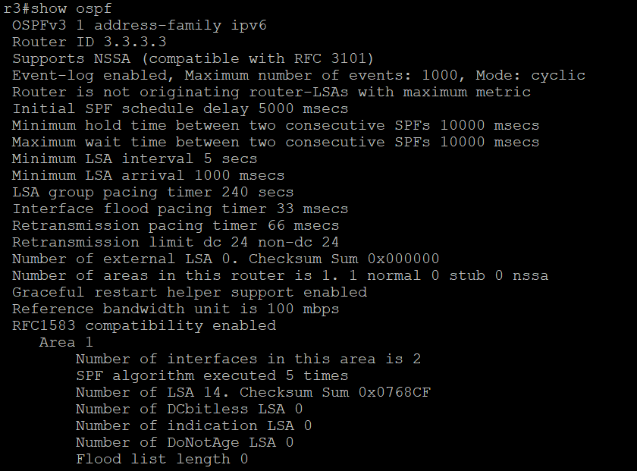
Router 4
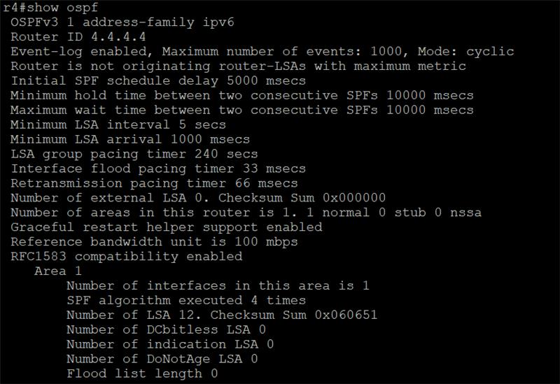
Router 5
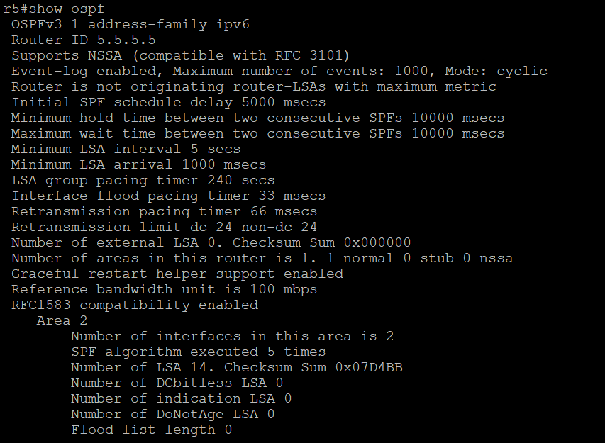

OSPF Info (show ospf)
Router 1 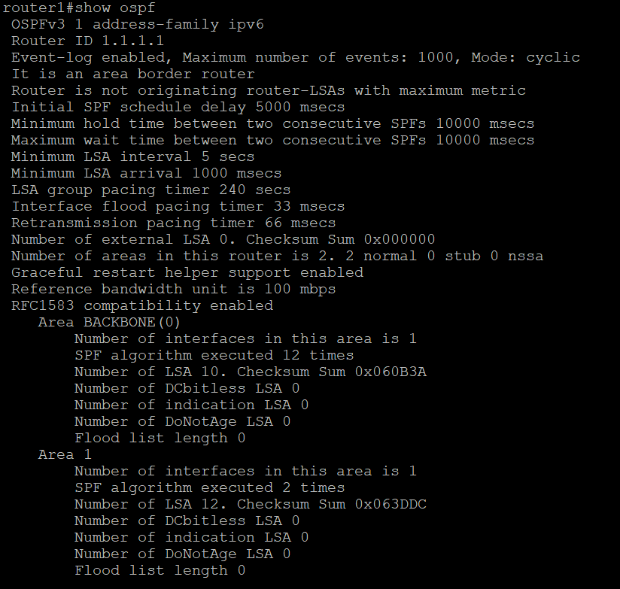
Router 2
Router 3
Router 4
Router 5

Problems:
While we were configuring the multi-Area OSPF, the routers would not display OSPF neighbors. We couldn’t figure it out even after spending a lot of time troubleshooting and talked to some other students about it. Finally, we were able to fix it and found that the issues were mistyped IPs on 2 of the routers. Fixing the IPs resolved the issue.
Conclusion:
We learned how to configure and troubleshoot Multi-Area OSPF on Cisco routers using both Packet Tracer for a better/cleaner view of the topology and PuTTY for configurations/information. The skills we learned included setting router IDs, planning and assigning interfaces to the correct OSPF areas, and ensuring connectivity across multiple routers/switches. The lab helped us hone our skills by giving us more experience doing configurations with PuTTY and by practicing making a topology for OSPF. We also practiced assigning IP’s for both IPv4 and IPv6, and gained familiarity with how OSPF worked, requirements for OSPF, and splitting the network up to increase optimization and scalability.

Sign-off Sheet:
